[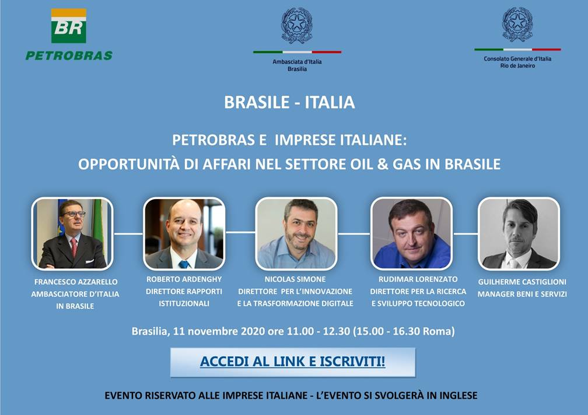](https://doity.com.br/petrobras-e-imprese-italiane-opportunita-di-business-in-brasile-nel-settore-oil-gas-1)

**Petrobras Overview**

We are a Brazilian company with over 40,000 employees, committed to generate more value for our shareholders and the society. We are one of the largest producers of oil and gas in the world, primarily engaged in exploration and production, refining, energy generation, trading and distribution of oil products. We have acquired expertise on deep & ultradeep water exploration & production as a result of almost 50 years developing the Brazilian offshore basins, becoming world leaders in this segment.

We have a large base of proved reserves and operate and produce most of Brazil’s oil and gas. Most of our proved reserves are world-class assets located in the adjacent offshore Campos and Santos Basins in southeast Brazil. Their proximity allows us to optimize our infrastructure and limit our costs of exploration, development and production. Additionally, we have developed technical knowledge in deepwater exploration and production from almost 50 years of developing Brazil’s offshore basins, including the Campos and Santos Basins.

Our business, however, goes beyond the oil and gas exploration and production. We operate most of the refining capacity in Brazil. Our refining capacity is substantially concentrated in southeast Brazil, within the country’s most populated & industrialized markets and adjacent to the sources of most of our crude oil in the Campos & Santos Basins. We meet our demand for oil products through a planned combination of domestic refining of crude oil and oil products imports, seeking value creation.

We also participate in the Brazilian natural gas market, including the logistics, distribution and processing of natural gas. To meet domestic demand, we process natural gas derived from our onshore and offshore production, import natural gas from Bolivia and import liquefied natural gas (“LNG”) through our regasification terminals. We also participate in the domestic power market primarily through our investments in gas-fired, fuel oil and diesel oil thermoelectric power plants and in renewable energy.